

USEFUL JAPANESE DICTIONARY FOR VIETNAMESE

Architecture Design

Project Code: UJD_VN

Document Code: UJD_VN_ Architecture Design_v1.3_EN

**Ha Noi, 16/08/2014**

Record of change

*A - Added M - Modified D - Deleted

|  |  |  |  |  |
| --- | --- | --- | --- | --- |
| Effective Date | Changed Items | A* M, D | Change Description | New Version |
| 07/07/2014 | Component diagram | M | Modified | v1.1 |
| 11/08/2014 | Sequence diagram | M | Modified | v1.2 |
| 16/08/2014 | Use-case view | M | Modified | v1.3 |
|  |  |  |  |  |
|  |  |  |  |  |
|  |  |  |  |  |
|  |  |  |  |  |
|  |  |  |  |  |
|  |  |  |  |  |
|  |  |  |  |  |

Table 1: Record of change

SIGNATURE PAGE

**ORIGINATOR:** Nguyen Ngoc Tuan 26/06/2014

Developer

**REVIEWERS:**

**APPROVAL:**  Nguyen Van Sang

Supervisor

TABLE OF CONTENTS

1 Introduction 6

1.1 Purpose 6

1.2 Scope 6

1.3 Definitions, Acronyms and Abbreviations 6

1.4 References 6

1.5 Overview 7

2 Choice of Architecture design 7

2.1 MVC Model 7

2.2 Codeigniter 9

3 Architectural Representation 10

4 Architectural Goals and Constraints 11

5 Use-Case View 12

5.1 User module 12

**1.5.1** 5.1.1 **Common module** 12

**1.5.2** **5.1.2 Account management module** 13

5.1.3 Contact admin module 14

5.2 Admin module 16

2.5.1 5.2.1 Admin account management 16

2.5.2 5.2.2 Member account management 16

5.2.3 Vocabulary management 17

5.2.4 Grammar management 18

5.2.5 Reading document management 19

5.2.6 Conversation management 20

6 Logical View 23

6.1 Overview 23

6.2 Architecturally Significant Design Packages 24

7 Process View 27

8 Deployment view 29

9 Quality 29

# Introduction

## Purpose

This document provides a comprehensive architectural overview of the system, using a number of different architectural views to depict different aspects of the system. It is intended to capture and convey the significant architectural decisions that have been made on the system.

## Scope

The scope of this document is to depict the architecture of the Useful Japanese Dictionary for Vietnamese website created by UJD_VN capstone project team.

## Definitions, Acronyms and Abbreviations

|  |  |  |
| --- | --- | --- |
| Acronym | Definition | Note |
| UJD_VN | Useful Japanese Dictionary for Vietnamese |  |
| MVC | Model view control |  |
| IDE | Integrated development environment |  |
| Q&A | Question and answer |  |
| GUI | Graphic user interface |  |

Table 2: Definitions

## References

* UJD_VN_ Software Requirements Specification_v1.0_EN.docx
* UJD_VN _Data Design_v1.0_EN.docx
* Sample Design at Introduction to software engineering (I2SE) course in cms.fpt.edu.vn
* Software Architecture Design Illuminated Book
* <http://en.wikipedia.org/wiki/Model-view-controller>

## Overview

The Software Architecture Document contains the following subsections:

* Section 1: Provide an overview of entire Software Architecture Document.
* Section 2: Choice of Architecture Design
* Section 3: Architectural Representation
* Section 4: Architectural Goals and Constraints
* Section 5: Use-Case view
* Section 6: Logical View
* Section 7: Process View
* Section 8: Deployment view.
* Section 9: Quality.

# Choice of Architecture design

## MVC Model

The purpose of UJD is developing a web application that supports users about Japanese. The system of UJD is structured based on MVC combined with layered architecture and Codeigniter framework

#### **MVC Model overview**

MVC is a software architecture pattern that separates the representation of information from user’s interaction with it. The model consists of application data, business rules, logic and functions. A view can be any output representation of data, such as a chart or a diagram. Multiple views of the same data are possible, such as bar chart for management and a tabular view for accountants. The controller mediates input, converting it to commands for the model or view.

The Model-View-Controller (MVC) design pattern assigns objects in an application one of three roles: model, view, or controller. The pattern defines not only the roles objects play in the application, it defines the way objects communicate with each other. Each of the three types of objects is separated from the others by abstract boundaries and communicates with objects of the other types across those boundaries. The collection of objects of a certain MVC type in an application sometimes referred to as a layer—for example, model layer.

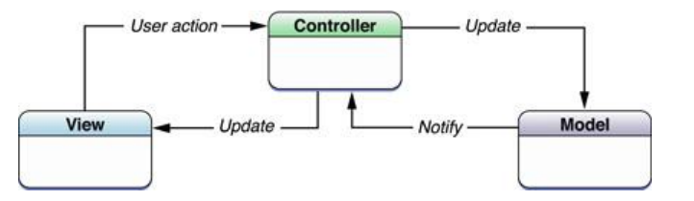

Figure 1: MVC Model

In addition to dividing the application into three kinds of components, the MVC design defines the interactions between them:

* **A controller:** can send commands to its associated view to change the view's presentation of the model (e.g., by scrolling through a document). It can also send commands to the model to update the model's state (e.g., editing a document).
* **A model:** notifies its associated views and controllers when there has been a change in its state. This notification allows the views to produce updated output, and the controllers to change the available set of commands. A passive implementation of MVC omits these notifications, because the application does not require them or the software platform does not support them.
* **A view:** requests from the model the information that it needs to generate an output representation to the user.

#### **Advantages and disadvantages of MVC model**

* Advantages:
* The MVC model demonstrates professionalism in programming and design analysis. It is divided into independent components to help develop applications faster, simpler, easier upgrades and maintenance.
* Many MVC vendor framework tool kits are available.
* Multiple views synchronized with same data model.
* Easy to change or plug in new interface views, allowing updating of interface views with new technologies without overhauling the rest of system.
* Very effective for deployment if graphic, programming and database development professionals are working in a team in a designed project.
* Disadvantages:
* For small projects that apply MVC model caused cumbersome, time consuming

in development process.

* Time consuming to transits data between components.
* Not suitable for agent-oriented applications such as interactive mobile and robotics applications.
* Multiple pairs of controllers and views based on the same data model make data model change expensive.
* The division between the View and the Controller is not clear in some cases.

#### **The reason of choosing MVC model**

* Easily manage the complexity of application by dividing the application into three components: model, view and controller.
* Better support for test-driven development.
* It is good support for application built by project team has many developers and designers but still managed application features.
* UJD system is not complete system, now. We built the system that towards extensibility and maintainability in the future.

## Codeigniter

#### **Codeigniter overview**

CodeIgniter is an open source rapid development web application framework, for use in building dynamic web sites with PHP. CodeIgniter is loosely based on the popular MVC development pattern. While view and controller classes are a necessary part of development under CodeIgniter, models are optional.

#### **Advantages and disadvantages of Codeigniter**

* Advantages:
* Designed according to the MVC Model
* CodeIgniter is a PHP framework have the fast speed
* CodeIgniter provides libraries cater to the most common tasks in web programming, such as database access, email, data checking, session management, image processing ... to the high function as XML-RPC, encryption, security ...
* Mechanism test data is closely, preventing XSS and SQL Injection of CodeIgniter helps minimize the security risk to the system.
* Disadvantages:
* No supports about some common module
* No supports about AJAX
* No support about **Event-Driven Programming**

#### **The reason of choosing Codeigniter**

* Consistent with UJD system
* Some modules need to reuse shared business logic layer.
* Designed according to the MVC Model

# Architectural Representation

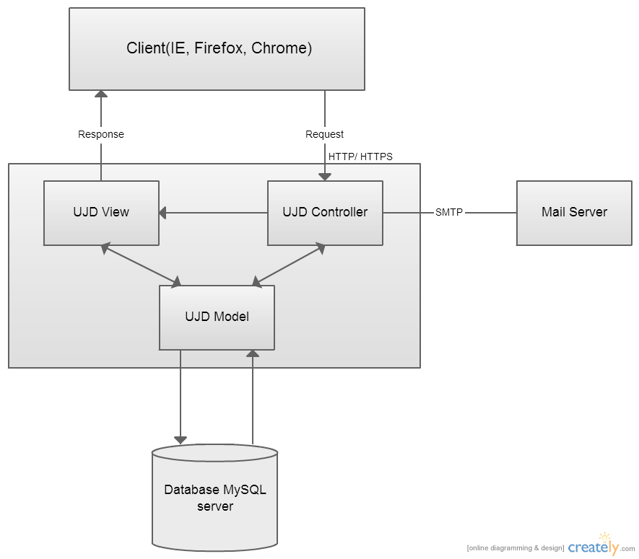

Figure 2: System overview

We follow MVC architecture to implement the UJD_VN Project. MVC offers architectural benefits over standard JavaScript — it helps us write better-organized and therefore more maintainable code.

**Model** is where the application’s data objects are stored. A model object is in charge of encapsulating application state and one object could be related to other objects establishing a one-to-one or one-to-many relationship. The model object does not talk directly to a View, instead is made available to a controller, which accesses it when needed. When a model changes, typically it will notify its observers that a change has occurred. As with any data object it contains instance variables and getter/setter methods.

**View** is what is presented to the users and how users interact with the system. The view is expected to render the model in a meaningful way to the user. In UJD, the view is made with .cshtml file including css, JavaScript or jQuery, it sends user gestures to controller and allows controller to select view.

**Controller** is the decision maker and the glue between the model and view; it handles user actions and gestures, and responds to user events. For example, in CMS, when a user clicks the “Create” button to create a new contract, the controller for that action is invoked.

The controller will then make changes to the contract model. The view will then render the modified contract model to the display so that user can view the new contract he added in the contract list.

# Architectural Goals and Constraints

**Availability:** The application must be available 95% of time. Users can access to it everywhere from there .Web browser with internet connection.

Maintainability:

* Coding standards and naming conventions
  + Output of the project must include coding standards and naming conventions documentations. Implementation code must be easy to maintain.
  + All code must be clearly commented, including class, method documentations.
  + If some components are reused, the documentations of those components must also be included.
* Design
  + The design of the system must be loosely coupled that chances on some module will not affect others.
* Logging
  + All the errors should be logged, supporting for bug fixing and maintenance.
  + All strange or sensitive situations should also be logged.

**Usability:** Usability Requirements support the following from the perspective of its primary users:

* *Efficiency of use***:** user can complete each function in less than 12 actions
* *Intuitiveness***:** all help/error messages are simple to understand; user can know exactly how to do each feature after one time using it.

**Capacity and scalability:** throughput, storage and growth requirements.

# Use-Case View

This application includes two parts:

* The first part is User module. User module includes member and visitor.
* Next part is Admin module. In admin side includes admin to manage vocabulary, grammar, video, test, listening, reading and manage member’s account.

## User module

### 5.1.1 **Common module**

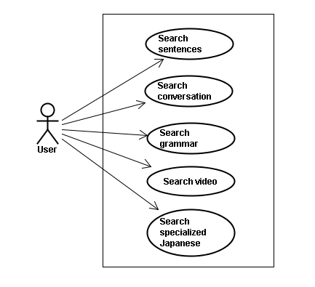

Figure 3: Common module

|  |  |  |  |
| --- | --- | --- | --- |
| **No** | **Use-case name** | **Actor** | **Description** |
| 1 | Search sentences | Member and Visitor | Search for example sentences |
| 2 | Search conversation | Member and Visitor | Search for conversations |
| 3 | Search grammar | Member and Visitor | Search for grammar |
| 4 | Search video | Member and Visitor | Search for video of Japanese |
| 5 | Search specialized Japanese | Member and Visitor | Search for Japanese specialized |

### **5.1.2 Account management module**

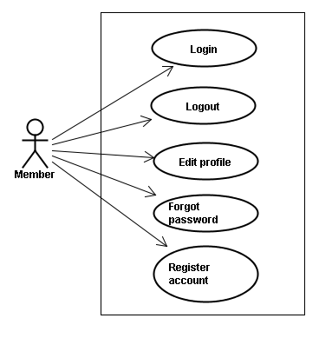

Figure 4: Account management

|  |  |  |  |
| --- | --- | --- | --- |
| **No.** | **Use-case name** | **Actor** | **Description** |
| 1 | Login | Member | Login to system |
| 2 | Logout | Member | Logout |
| 3 | Edit profile | Member | Edit member’s profile |
| 4 | Forgot password | Member | Forgot password |
| 5 | Register account | Member | Register account for customers to use more features of the website |

### **Contact admin module**

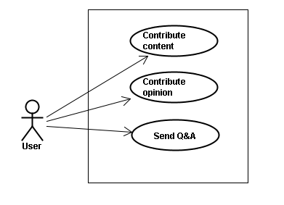

Figure 5: Contact admin

|  |  |  |  |
| --- | --- | --- | --- |
| **No.** | **Use-case name** | **Actor** | **Description** |
| 1 | Contribute content | Member and Visitor | Contribute useful database for website |
| 2 | Contribute opinion | Member and Visitor | Feedback for website development |
| 3 | Send Q&A | Member and Visitor | Send any questions in the process of using Website |

* + 1. **Practice module**

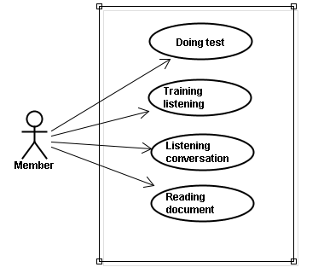

Figure 6: Practice

|  |  |  |  |
| --- | --- | --- | --- |
| **No.** | **Use-case name** | **Actor** | **Description** |
| 1 | Doing test | Member | Doing test and tracking the learning process |
| 2 | Training listening | Member and Visitor | Training listening level N2,N3,N4 |
| 3 | Listening conversation | Member and Visitor | Listening conversation |
| 4 | Reading document | Member and Visitor | Reading document |

## Admin module

### **5.2.1 Admin account management**

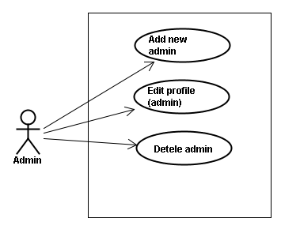

Figure 7: Admin account management

|  |  |  |  |
| --- | --- | --- | --- |
| **No.** | **Use-case name** | **Actor** | **Description** |
| 1 | Add new admin | Admin | Add new admin |
| 2 | Edit profile (admin) | Admin | Edit profile admin |
| 3 | Delete admin | Admin | Delete admin |

### **5.2.2 Member account management**

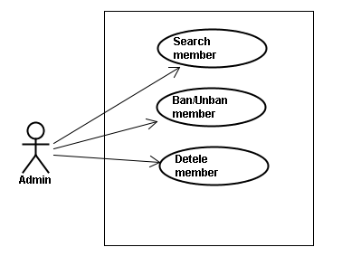

Figure 8: Member account management

|  |  |  |  |
| --- | --- | --- | --- |
| **No.** | **Use-case name** | **Actor** | **Description** |
| 1 | Search member | Admin | Search member |
| 2 | Ban/Unban member | Admin | Ban/Unban member |
| 3 | Delete admin | Admin | Delete member |

### **Vocabulary management**

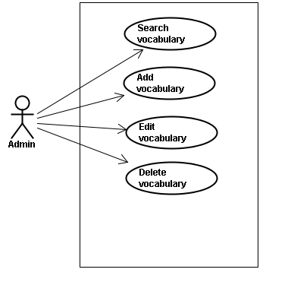

Figure 9: Vocabulary management

|  |  |  |  |
| --- | --- | --- | --- |
| **No.** | **Use-case name** | **Actor** | **Description** |
| 1 | Search vocabulary | Admin | Search vocabulary |
| 2 | Add vocabulary | Admin | Add new vocabulary |
| 3 | Edit vocabulary | Admin | Edit vocabulary |
| 4 | Delete vocabulary | Admin | Delete vocabulary |

### **Grammar management**

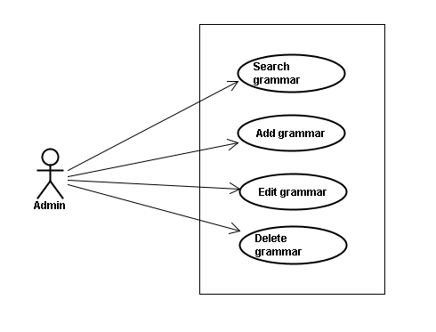

Figure 10: Grammar management

|  |  |  |  |
| --- | --- | --- | --- |
| **No.** | **Use-case name** | **Actor** | **Description** |
| 1 | Search grammar | Admin | Search grammar |
| 2 | Add grammar | Admin | Add new grammar |
| 3 | Edit grammar | Admin | Edit grammar |
| 4 | Delete grammar | Admin | Delete grammar |

### **Reading document management**

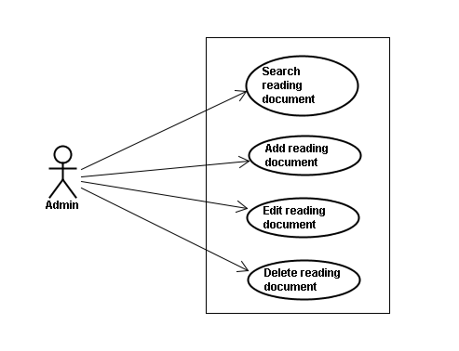

Figure 11: Reading document management

|  |  |  |  |
| --- | --- | --- | --- |
| **No.** | **Use-case name** | **Actor** | **Description** |
| 1 | Search reading document | Admin | Search reading document |
| 2 | Add reading document | Admin | Add new reading document |
| 3 | Edit reading document | Admin | Edit reading document |
| 4 | Delete document | Admin | Delete document |

### **Conversation management**

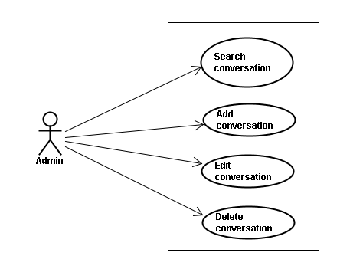

Figure 12: Conversation management

|  |  |  |  |
| --- | --- | --- | --- |
| **No.** | **Use-case name** | **Actor** | **Description** |
| 1 | Search conversation | Admin | Search conversation |
| 2 | Add conversation | Admin | Add new conversation |
| 3 | Edit conversation | Admin | Edit conversation |
| 4 | Delete conversation | Admin | Delete conversation |

* + 1. Video management

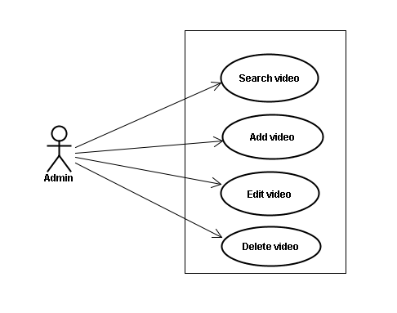

Figure 13: Video management

|  |  |  |  |
| --- | --- | --- | --- |
| **No.** | **Use-case name** | **Actor** | **Description** |
| 1 | Search video | Admin | Search video |
| 2 | Add video | Admin | Add new video |
| 3 | Edit video | Admin | Edit video |
| 4 | Delete video | Admin | Delete video |

* + 1. **Training listening management**

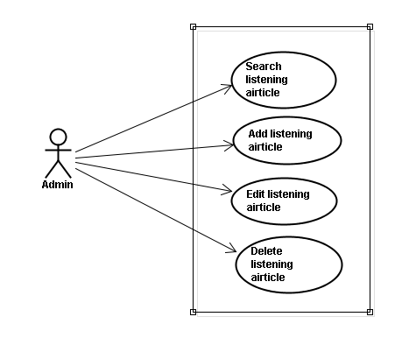

Figure 14: Training listening management

|  |  |  |  |
| --- | --- | --- | --- |
| **No.** | **Use-case name** | **Actor** | **Description** |
| 1 | Search listening | Admin | Search listening |
| 2 | Add listening | Admin | Add new listening |
| 3 | Edit listening | Admin | Edit listening |
| 4 | Delete listening | Admin | Delete listening |

* + 1. **Test management**

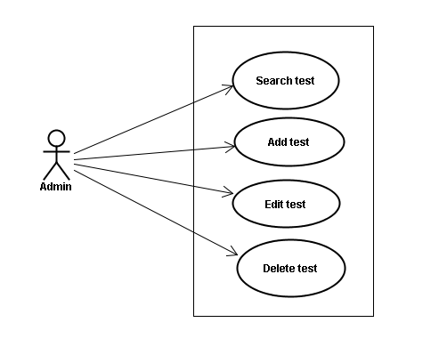

Figure 15: Test management

|  |  |  |  |
| --- | --- | --- | --- |
| **No.** | **Use-case name** | **Actor** | **Description** |
| 1 | Search test | Admin | Search test |
| 2 | Add test | Admin | Add new test |
| 3 | Edit test | Admin | Edit test |
| 4 | Delete test | Admin | Delete test |

* + 1. **Contact management**

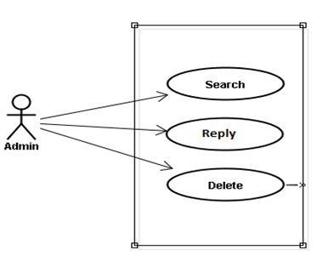

Figure 16: Contact management

|  |  |  |  |
| --- | --- | --- | --- |
| **No.** | **Use-case name** | **Actor** | **Description** |
| 1 | Search contact | Admin | Search contact |
| 2 | Reply con  tact | Admin | Reply contact |
| 3 | Delete contact | Admin | Delete contact |

# Logical View

## Overview

Logical View includes Package diagram and Class diagram. Package diagram describes the organization of packages and elements. Class Diagram provides an overview of the target system by describing the objects and classes inside the system and the relationships between them. It provides a wide variety of usages; from modeling the domain-specific data structure to detailed design of the target system

* Controller contain the interface between
* Associated models
* Associated views
* The input devices (e.g., keyboard, pointing device, time).
* Send commands to the model to update the model's state.
* Model is:
  + the domain-specific software simulation
  + Or implementation of the application's central structure.
* View deal with everything graphical
* Requests data from their model
* Display the data

## Architecturally Significant Design Packages

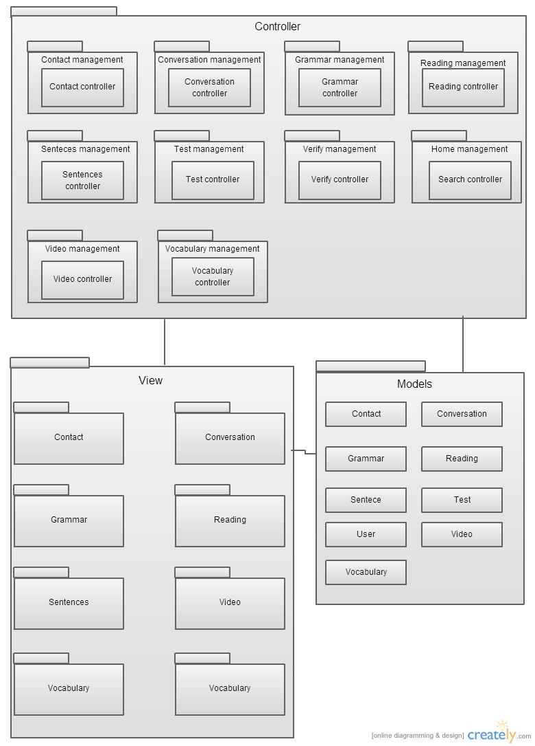

Figure 17: Package Diagram

* Model

|  |  |  |
| --- | --- | --- |
| **No.** | **Controller class** | **Role** |
| 1 | Contact | Description entity of Contact in database |
| 2 | Conversation | Description entity of Conversation in database |
| 3 | Grammar | Description entity of Grammar in database |
| 4 | Reading | Description entity of Reading in database |
| 5 | Sentence | Description entity of Sentence in database |
| 6 | Test | Description entity of Test in database |
| 7 | User | Description entity of User in database |
| 8 | Video | Description entity of Video in database |
| 9 | Vocabulary | Description entity of Vocabulary in database |

* Controller

|  |  |  |
| --- | --- | --- |
| **No.** | **Controller class** | **Role** |
| 1 | ContactController | * Receive request contact’s information from client. * Handle request from client and call method in Contact Model to get data from Database. * Respond data back to Contact View. |
| 2 | ConversationController | * Receive request conversation’s information from client. * Handle request from client and call method in Conversation Model to get data from Database. * Respond data back to Conversation View. |
| 3 | GrammarController | * Receive request grammar’s information from client. * Handle request from client and call method in Grammar Model to get data from Database. * Respond data back to Grammar View. |
| 4 | ReadingController | * Receive request reading’s information from client. * Handle request from client and call method in Reading Model to get data from Database. * Respond data back to Reading View. |
| 5 | SentenceController | * Receive request sentence’s information from client. * Handle request from client and call method in Sentence Model to get data from Database. * Respond data back to Sentence View. |
| 6 | TestController | * Receive request test’s information from client. * Handle request from client and call method in Test Model to get data from Database. * Respond data back to Test View. |
| 7 | VerifyController | * Receive request user’s information from client. * Handle request from client and call method in User Model to get data from Database. * Respond data back to Homepage View. |
| 8 | SearchController | * Receive request search’s information from client. * Handle request from client and call method in Search Model to get data from Database. * Respond data back to Search View. |
| 9 | VideoController | * Receive request video’s information from client. * Handle request from client and call method in Video Model to get data from Database. * Respond data back to Video View. |
| 10 | VocabularyController | * Receive request vocabulary’s information from client. * Handle request from client and call method in Vocabulary Model to get data from Database. * Respond data back to Vocabulary View. |

* View

Include many .php files

# Process View

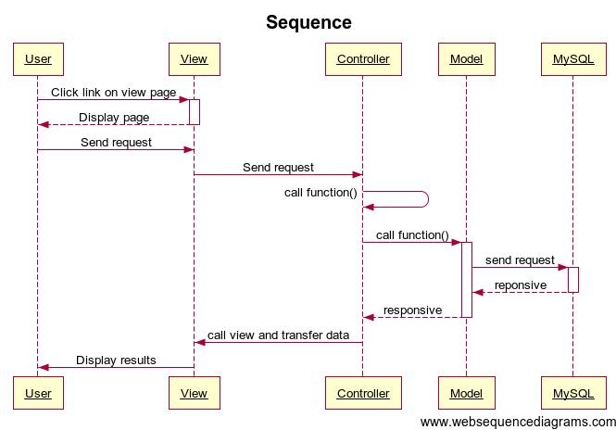

Figure 18: Sequence diagram

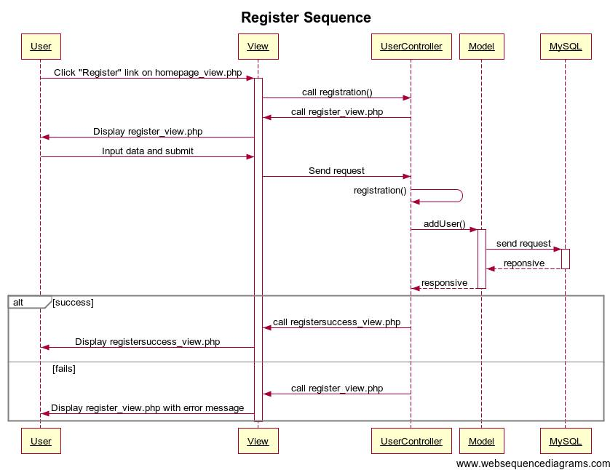

Figure 19: Register sequence

By click on "Đăng ký" link, user send a request register to usercontroller class usercontroller class call function registration() and return view to register page (register_view.php)

User enter username, password, repassword, fullname, email and submit Registration (validate) will be invoked.

If data entered is valid and username and email is unique in database, function registration() will call function addUser($user) in User_model.

Funtion addUser($user) will insert a new record to user table in database MySQL and responsive to registration() in usercontroller.

After that, function registration() will call funtion thank() to return registersuccess_view. If data entered is invalid or username and email is exits, usercontroller class will return Register page with error.

# Deployment view

Deployment view of website

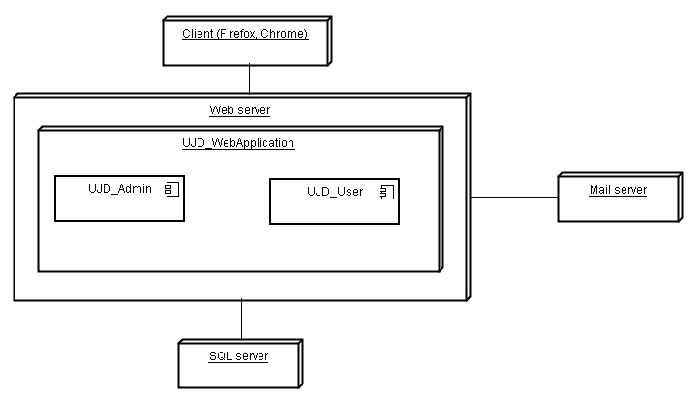

Figure 19: Deployment view

|  |  |  |
| --- | --- | --- |
| **No.** | **Name** | **Description** |
| 1 | MySQL sever | MySQL server use to store system’s data. MySQL5.6.16 or higher |
| 2 | Mail server | Mail server use to interact with user’s email |
| 3 | Web server | Web server is host system’s website. |
| 4 | Client | Client is web browser to use system. Firefox 20, Chrome 36 or higher. |

# Quality

Reference to: “UJD_VN_Software requirement specification_v1.2_EN”